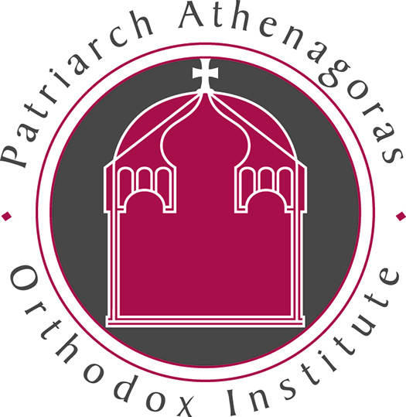
Patriarch Athenagoras Orthodox Institute
Fall 2013 Course Offerings

Asceticsm: For Love of God – Mother Melania Tuesdays, 12:40 – 3:30
Asceticism has taken on almost entirely pejorative connotations to many modern ears. Yet the motivation of true Christian asceticism is love for God. St. John of the Ladder defines chastity as “a divine love that drives out bodily love, an overcoming of nature by grace.” Such love is very active and determined. It is no accident that the root meaning of ascesis is athletic training. The true ascetic trains himself unstintingly to strive towards the God Whom he loves above all things.
In this course, we will explore some fundamental ascetic texts of the Church, including Evagrius' Praktikos, St. Basil the Great's Long and Short Rules, St. John Climacus' The Ladder of Divine Ascent; St. John Cassian's Institutes of the Coenobium, and The Rule of St. Benedict; along with later texts such as The Unseen Warfare and The Arena. We will also look at divergent attitudes towards asceticism between East and West, with a view towards understanding our own cultural attitudes toward asceticism.

Lamentation in Ancient Greek and Christian Traditions – Metropolitan Nikitas & Dr. Alexandra Turkington, Monday 12:40 – 3:30
This course will serve as a study of the tradition and evolution of the lament in ancient Greek Literature and Christian hymnology and writings. Focus will be primarily, but not only, on women and their expression of lament. Issues pertaining to the continuity of the lamentation tradition within the ancient Greek and later Christian tradition will be examined, including the theological, historical and poetic messages. The course combines lecture and seminar formats. An evaluation will be based on preparation and class participation, an on-class presentation of a lament in the classical or Christian traditions, and a final reflection paper.

The Ethics of Theosis – Metropolitan Nikitas & Ann Woods, Thursday 12:40 – 3:30
This course will explore the Orthodox Christian approach to ethics, based on the doctrine of theosis. The focus will be on understanding the basic vocabulary, tools, and sources of Orthodox ethics, with opportunities for students to investigate specific issues in their written work. Readings will draw primarily on contemporary authors with some readings from historical sources. Previous knowledge of Orthodox theology will be helpful, but not required.

Orthodox Christian Church: History and Theology, Dr. John Klentos Tuesday, 9:40 – 12:30
This course is an introductory survey of the history and theology of the Orthodox Christian
Church. Beginning with the Church's pre-Byzantine roots, the course will sketch the development of Orthodox Christianity through the Christological, Trinitarian, and iconoclastic controversies. Historical inquiry will be given to topics such as sin, salvation, and eschatology, as well as Byzantine art, music, and liturgy. The course combines lecture and seminar formats. Evaluation based on classroom participation, one short paper, a classroom presentation, and a final synthesis paper.

Christ and Spirit in Liturgy – Dr. John Klentos Thursday, 9:40 – 12:30
Theology and Liturgy are related --intrinsically related-- to one another. What a people believe about God influences how they praise, pray, and worship; how a people praise, pray, and worship influences what they believe about God. This course will concentrate primarily (but not exclusively) on how Christian liturgies from diverse times and places reflect particular Christological and Pneumatological understandings. Who are the Christ and the Spirit depicted in liturgy? What is the place of Christ in liturgy? What is the place of the Spirit in liturgy? Historical investigation and theological reflection will help students better understand the connections between worship & Christology and worship & Pneumatology, allowing them to better address modern questions concerning God and Christian worship.
Besides reading modern theologians and liturgiologists, students will encounter a variety of liturgical texts (prayers, hymns, homilies) reflecting Eastern (& Oriental Orthodox) and Western (Catholic & Protestant) traditions, ranging from the 2nd century into the early 21st century. Class format will be mainly seminar with some lectures. Students will be evaluated on classroom participation (reflecting careful reading of assignments and synthetic reflection), and four short (5-7 page) papers.

Patriarch Athenagoras Orthodox Institute
2311 Hearst Avenue
Berkeley, CA 94709
510 649 3450
www.orthodoxinstitute.org

